THE UNIVERSITY OF AZAD JAMMU & KASHMIR, MUZAFFARABAD


COURSE TITLE | I&CT
COURSE CODE | HU-1104
LAB TITLE | VIRTUAL COLLABORATION TOOLS
STUDENT NAME | HASEEB SHEIKH
STUDENT ROLL NUMBER | 2024-SE-31
INSTRUCTOR NAME | ENGR. TAHIR ABBASI
SUBMISSION DATE | FEBRUARY 26, 2025

DEPARTMENT OF SOFTWARE ENGINEERING
I&CT
Lab 9

Learning Experience Summary

In this lab, I gained valuable skills in managing and organizing files using Google Drive. I learned how to create folders, upload different types of files, and organize them into subfolders for better structure. Additionally, I explored the sharing settings, enabling me to share folders with varying access levels efficiently. Using Trello, I discovered effective methods for organizing tasks, creating lists, and collaborating with team members in a visually appealing way. This hands-on experience has enhanced my proficiency in cloud-based file management and collaboration tools, making me feel more confident in managing both personal and professional tasks.

Acknowledgments
- I would like to thank my classmate Abdul Rehman for his collaboration and insights, which enriched my understanding of the tasks.

- A special mention to Engineer Tahir Abbasi for his innovative teaching approach and dedication to fostering a collaborative and dynamic learning environment.

I&CT
Lab 9
Task 1: Google Drive - File Management and Sharing

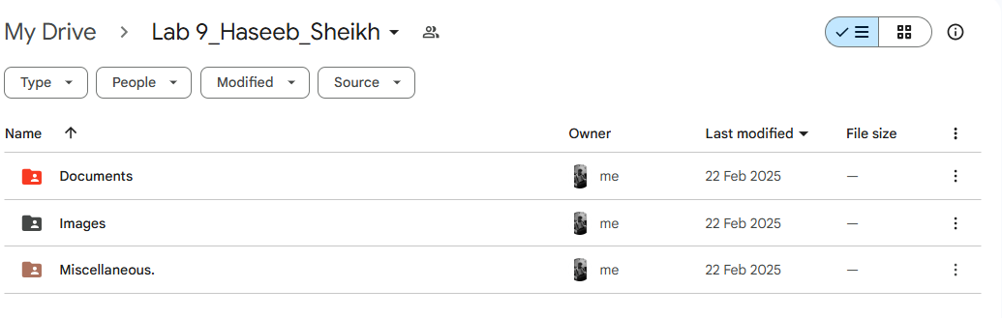
Lab 9 Folder
Figure 1: Screenshot showing the Lab 9_Haseeb folder

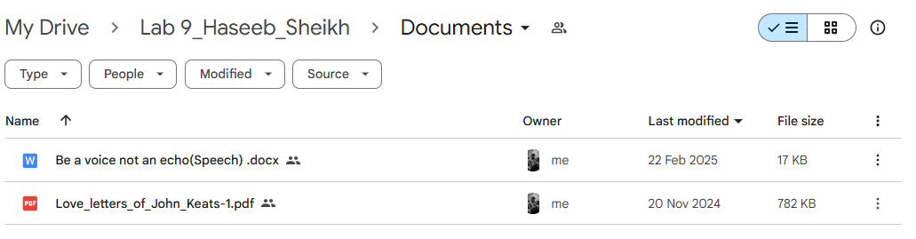
Documents Folder
Figure 2: Screenshot showing the 'Documents' subfolder.
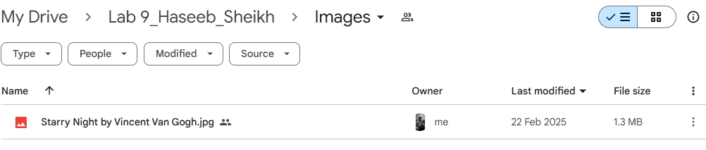
Images Folder
Figure 3: Screenshot showing the 'Images' subfolder.

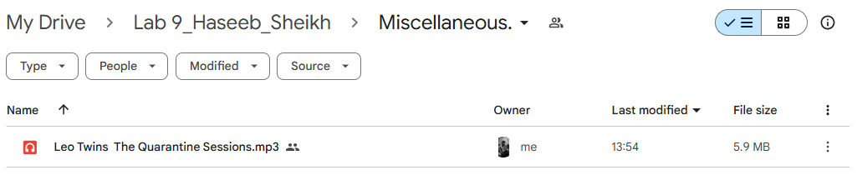
Miscellaneous Folder
Figure 4: Screenshot showing the 'Miscellaneous' subfolder.

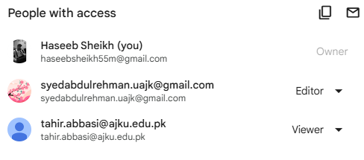
Sharing Settings

Figure5:Folder Settings.
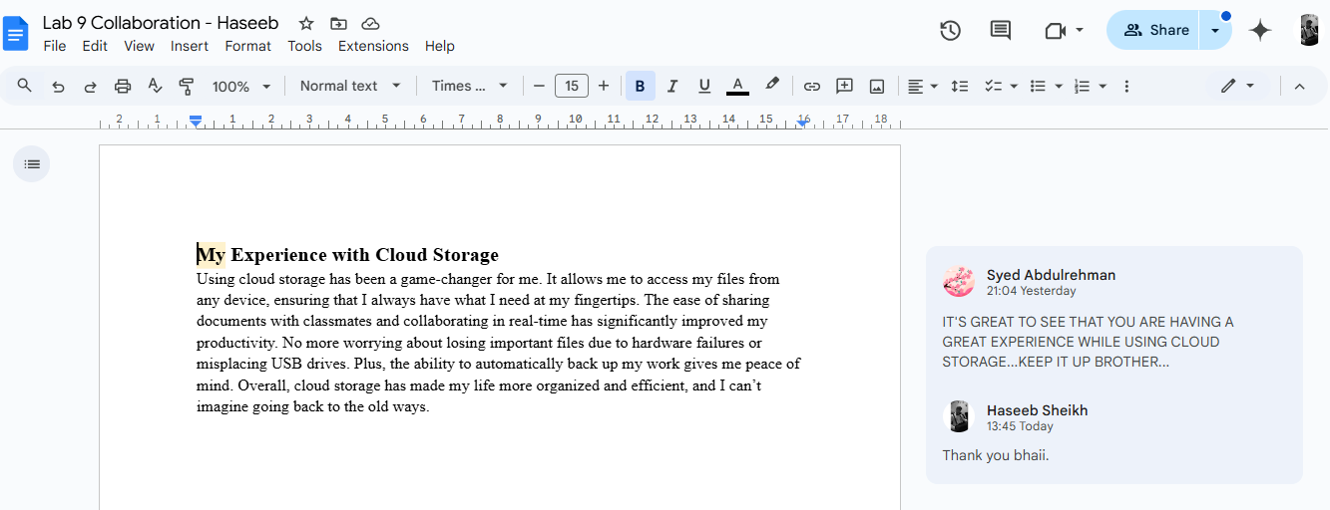
Task 2: Collaboration on a Document
Figure 6: screenshot showing the document with the comment and reply.

Task 3: Trello - Creating and Managing a Board

Trello Board
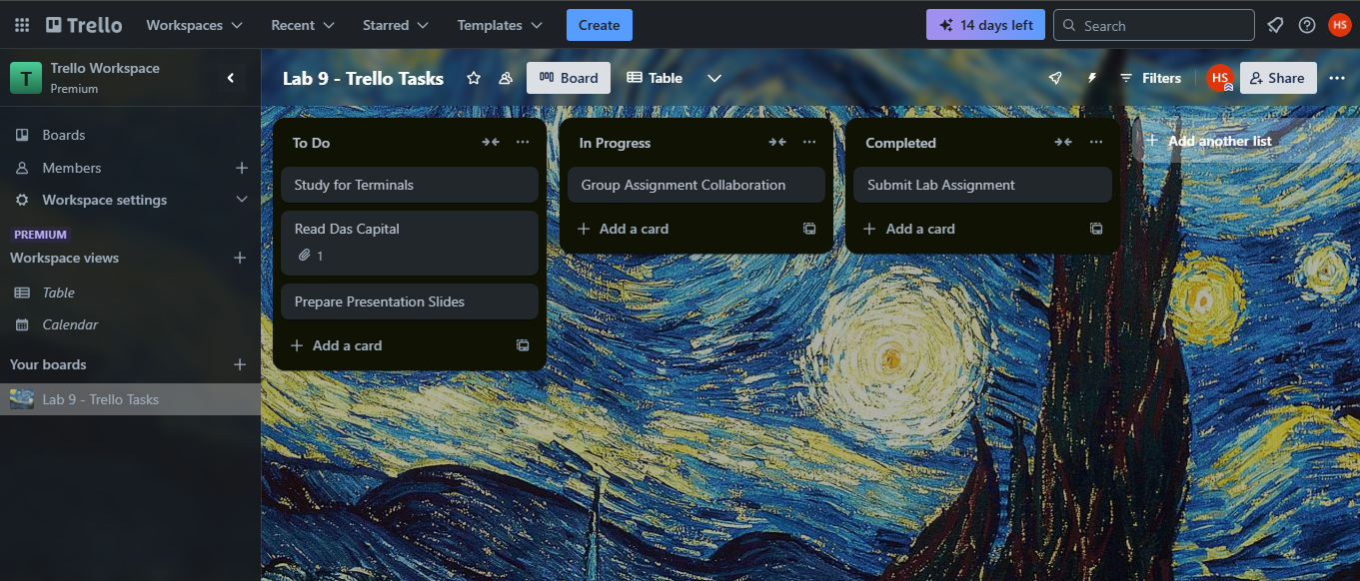

Figure 7: Screenshot showing lists and all tasks organized.

Sharing The Board
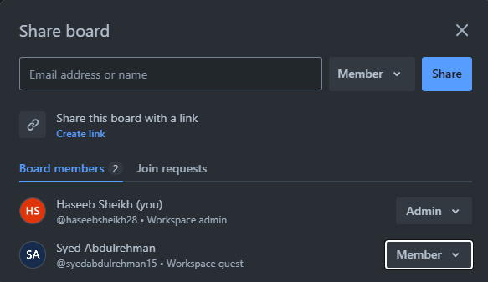

Figure 8: Screenshot showing the board sharing.

Task 4: Assigning and Managing Tasks in Trello
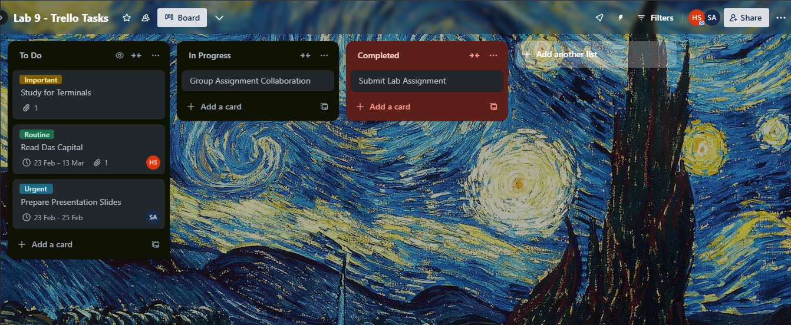

Figure 9: screenshot showing the assigned tasks with labels and attachments.

